**The SQL SETUP**

Setting up carbon_nanotubes data:

Create Table and columns

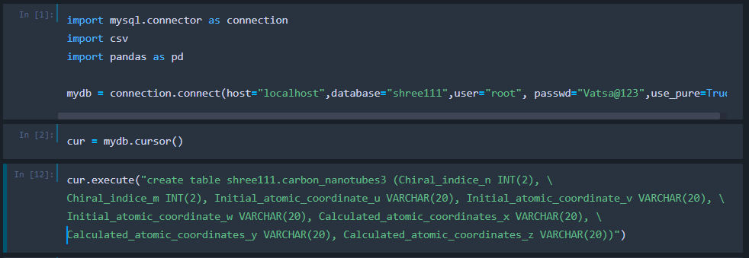

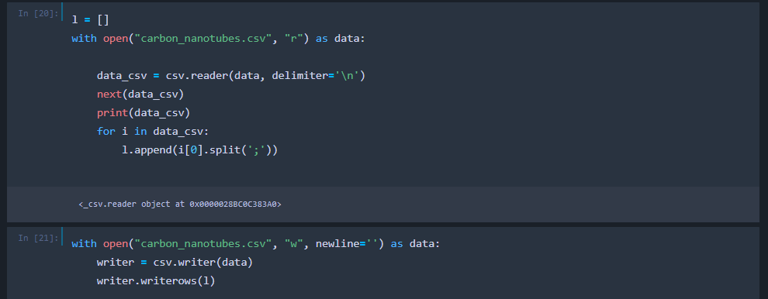

Inserting values:

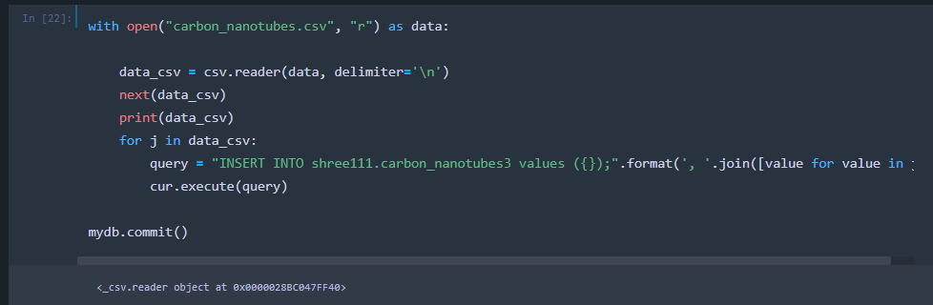

Alter -> Add a column Assignee -> Replace all null values with name “Shree”

Then read the data

Queries used:

ALTER TABLE shree111.carbon_nanotubes3 ADD Assignee VARCHAR(100) FIRST;

UPDATE shree111.carbon_nanotubes3 SET Assignee='Shree' WHERE Assignee IS NULL;

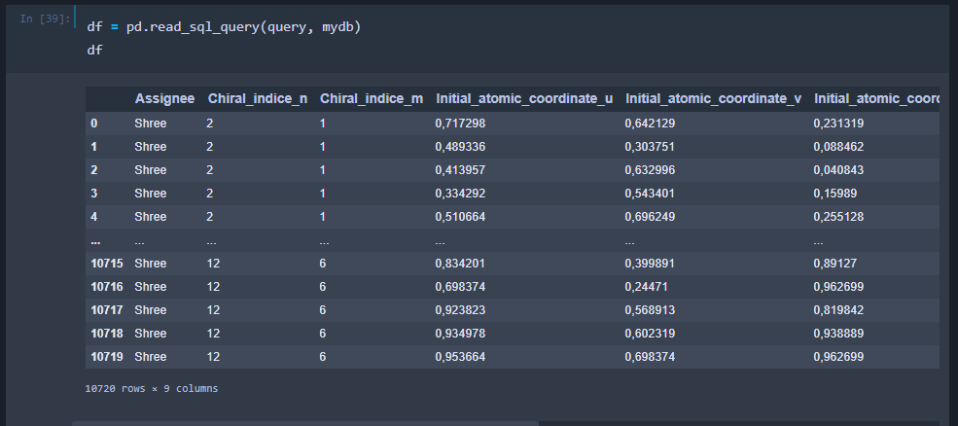

**The SQL SELECT QUERY**

## The SQL SELECT DISTINCT

1. Select first 2 columns of the table

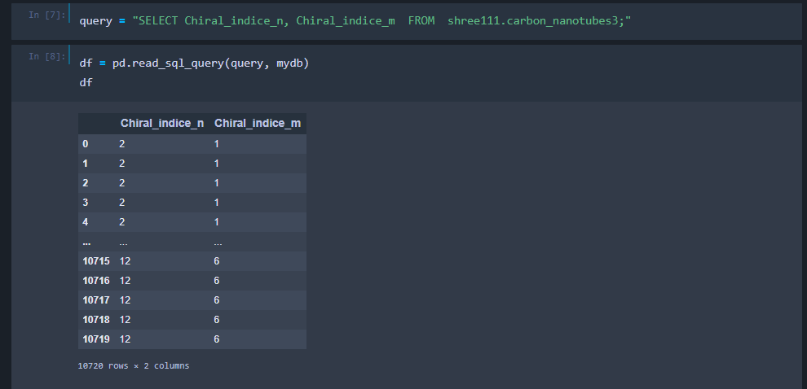

1. Select distinct elements from the column

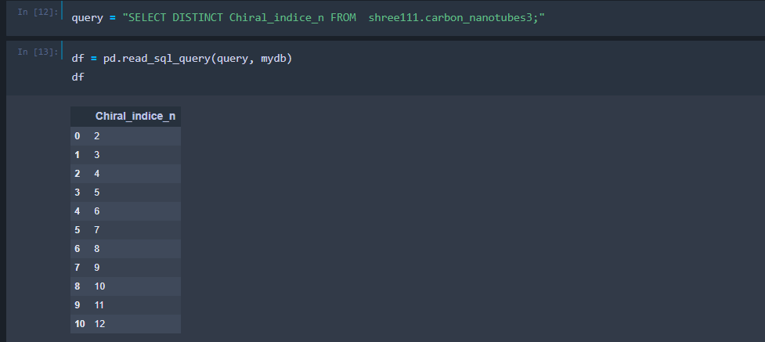

## The SQL WHERE CLAUSE

SELECT Chiral_indice_n, Initial_atomic_coordinate_v FROM shree111.carbon_nanotubes3 WHERE Chiral_indice_m = 3;

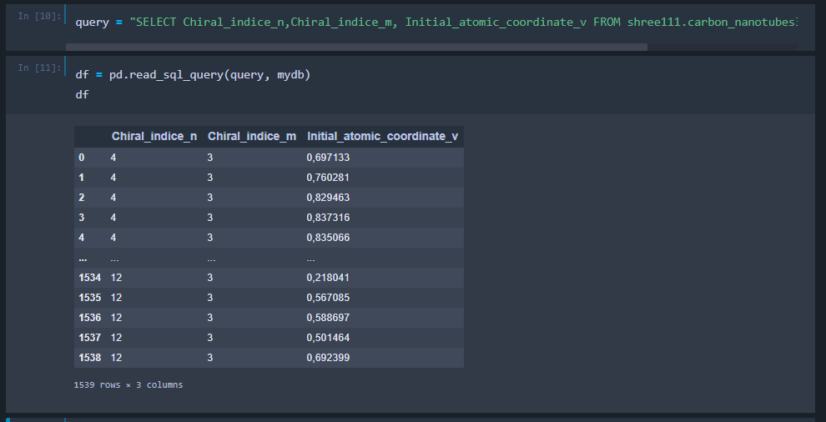

## The SQL WHERE CLAUSE WITH AND, OR & NOT

**A WHERE clause with AND**:

SELECT Chiral_indice_n,Chiral_indice_m, Initial_atomic_coordinate_v FROM shree111.carbon_nanotubes3 WHERE Chiral_indice_n = 5 AND Chiral_indice_m = 3;

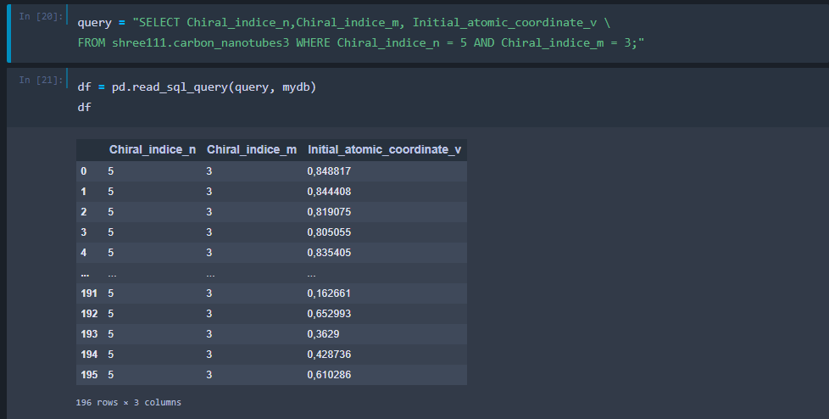

**A WHERE clause with NOT:**

Select Chiral_indice_n, Chiral_indice_m FROM shree111.carbon_nanotubes3 WHERE NOT Chiral_indice_m in (1,2,3,4,5)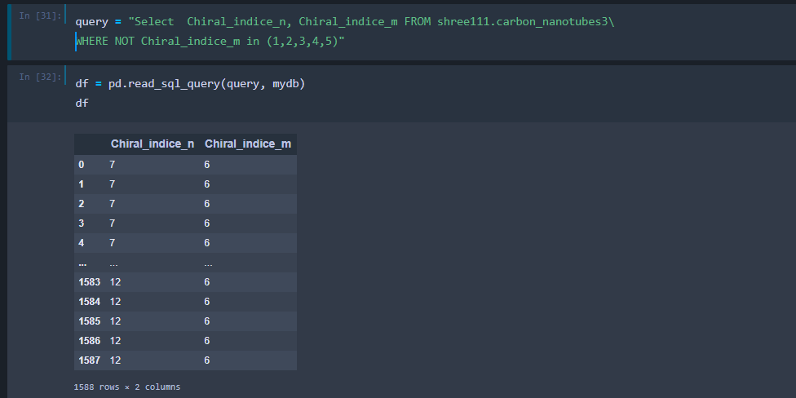

## The SQL ORDER BY

Order by is used to print the values from the table in order(ascending or descending)

**Order By in Descending order**

Select Chiral_indice_n, Chiral_indice_m FROM shree111.carbon_nanotubes3 ORDER BY Chiral_indice_n DESC;

